Challenge Problems and Applications
[to do]
put in something about finding the right transformation that will make a piecewise function continuous. Solving for the parameter that does it. And then an afterward about c0, c1 and c2 continuity

Something about inverse kinematics.

parametric challenge problems

1). Linear motion between arbitrary points
a). [warmup] Design a parametric curve that goes from some P1 to some P2 in a line as t goes from 0 to 1. For example, you might choose to go from (-5, 9) to (13, 22). (It doesn’t matter what happens before t = 0 or after t = 1).
b). Can you modify your equations so it goes from P1 to P2 and then back to P1 again? [ hint: use the absolute value function, or a quadratic ]
c). Choose specific coordinates for THREE different points, P1, P2 and P3. Can you design one that goes from P1 = (x1, y1) to P2 = (x2, y2) to P3 = (x3, y3) on whatever timeline you want?
Hint: graph x(t) and y(t) first. Then ask: what function could fit the values I want?

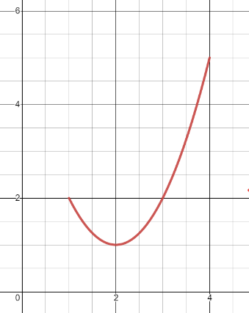
5). Here’s part of a parabola.
P2
P1

a). Define x(t) and y(t) so at t = 1 the path starts at p1 and at t = 4 it ends at p2.
b). Define a different x(t) and y(t) so the path starts at p1 at t = 0, and ends at p2 at t = 3.
c). Define an x(t) and y(t) so the path starts at p1 at t = 10 and ends at p2 at t = 13.
d). Define an x(t) and y(t) so the path starts at p1 at t = 0 and ends at p2 at t = 1.
e). Define an x(t) and y(t) so that the path starts at p2 at t = 0 and ends at p1 and t = 1

2). A nice way to force a path to loop back to the x and y axis
(a). Consider this pair of parametric equations $x\left(t\right)=\left(t-9\right)⋅{\left(t-11\right)}^{2}$ $y\left(t\right)=t⋅(t-11)$ on $t≥0$
Use desmos to sketch graphs of y = x(t) and y = y(t) separately. (remember to name them something else like f(t) and g(t) since x(t) and y(t) are specially reserved names).
Where and at what times will the path described by these equations cross the x-axis? The y axis? The origin? (How could you predict just based on the equations?)
(b). Load up the parametric curve explorer from before and check the path.
(c). Design your own parametric equations with different x(t) and y(t) which will cross the origin at t = 4 and t = 10.

